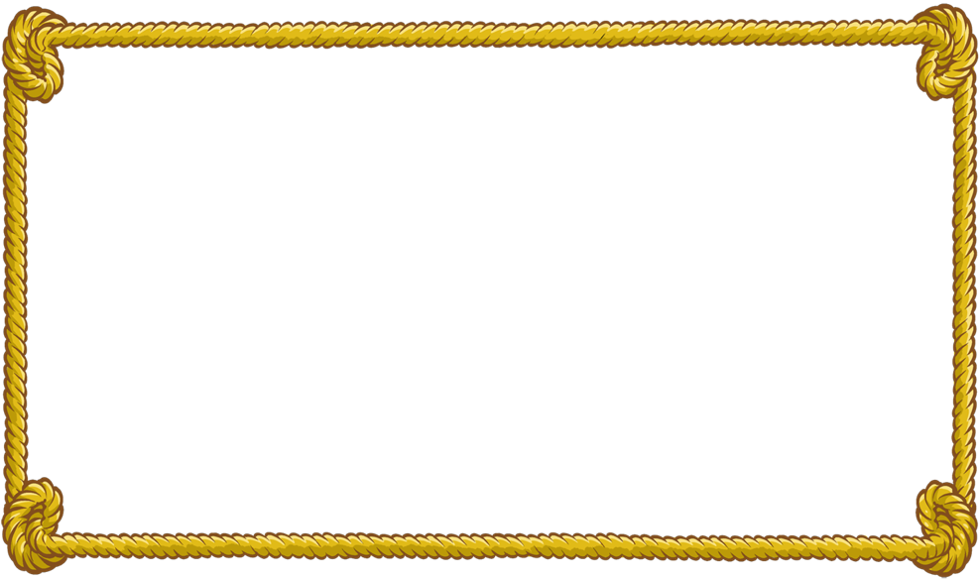 Dr. Yanga’s Francisco Balagtas

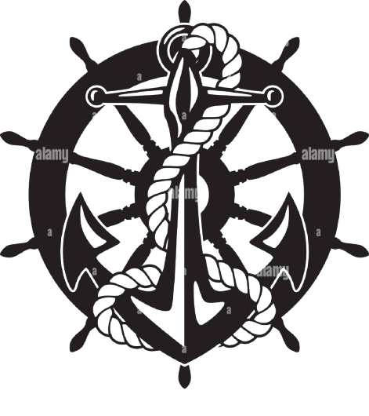

College

●Seaman Institute●

Certificate

This is to certify that **Virgilio C. Dela Cruz Jr.** has satisfactorily completed the Six-Month Basic Seaman Training Course prescribed by the Ministry of Higher Education, in coordination with the Philippine Coast Guard, Maritime Industry Authority, and National Seamen’s Board.

Given this **12th** day of **November**, **1992** at Bocaue, Bulacan, Philippines.

___________ ____________

Director President

